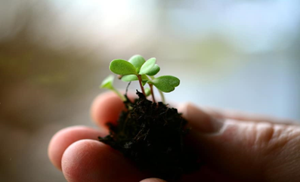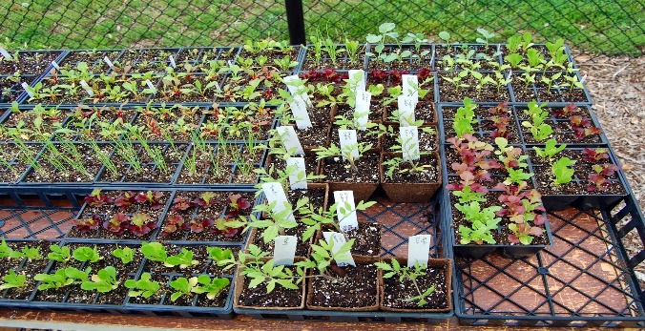
This Photo by Unknown Author is licensed under CC BY-SA-NC

Project: June Garden Fair (always the first Saturday in June)

Project Coordinator: Tim Schindele

Explanation of the Project: The June Garden Fair is an outdoor educational event that will be in front of and near the OSU Extension Service office in Redmond. The June Garden Fair will include the COMGA Plant Sale and other vendors selling garden related items and plants, a mobile Plant Clinic booth, Central Oregon insect display, the OSU Extension Service Demonstration Garden, and 10-minute University presentations. The COMGA Plant Sale will be just outside the OSU Demo Garden near the Rodeo Entrance and the vendors will be out in Parking Lot J. The vegetable plants being offered for sale at the COMGA Plant Sale are grown in the OSU Extension Service greenhouse and the tomato plants are from a local commercial grower. Our perennials are from WinterCreek Nursery. COMGA also sells row cover and soil thermometers. Other agency and non-profit organizations may have educational booths and displays at the June Garden Fair.
Volunteers needed: We invite trainees to join certified OSU Master Gardeners in all aspects of the June Garden Fair, including seeding germination trays, transplanting the seedlings, and moving, monitoring and watering plants inside the greenhouse.
There are limited sign-up slots for seed sowing that starts in late March into April and seedling transplanting in April into May. A seed sowing or transplanting shift would be about 2 hours.
On the day of the June Garden Fair, we need many volunteers for setup early that morning and breakdown at the end of the day. We’ll be setting up shade tarps, tables and chairs, moving plants from the Greenhouse to the outdoor tables, putting up labeling and signage, filling pre-paid orders and assisting customers.
When does the event/project occur? The June Garden Fair is Saturday, June 1, 2024. Setup begins at 7:00 AM, customers begin arriving at 9:00 AM, COMGA Plant Sale ends at 1:00 PM, followed by breakdown and cleanup. Suggested number of hours to volunteer is 2-4 hours. Being flexible with your time that day really helps with the scheduling.
How to sign up: Contact Tim Schindele (tjsfishes@bendbroadband.com) 206-819-5396 call/text
Additional enticements: Learn about greenhouse operations, how and when to sow seeds and transplant seedlings. Meet fellow Master Gardeners and have a great time while earning volunteer project hours which you need to become certified. This is one of the major fundraisers for COMGA which donates significant amounts to OSU Extension Service projects.

